LAB 5

Don’t use SetCursorPosition command in any question.

1- Write a program that takes n value from the user and prints an identity matrix with nxn dimension.

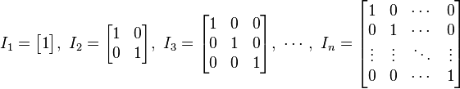

2- Write a program that prints the following output by using nested loops.
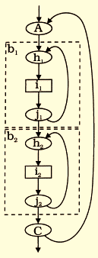
8 x 2 = 16
8 x 3 = 24
8 x 4 = 32
8 x 5 = 40
8 x 6 = 48
10 x 2 = 20
10 x 3 = 30
10 x 4 = 40
10 x 5 = 50
10 x 6 = 60
12 x 2 = 24
12 x 3 = 36
12 x 4 = 48
12 x 5 = 60
12 x 6 = 72

3- Write a program that prints the following shape by using nested loops.


123456789
2345678
34567
456
5
456
34567
2345678
123456789

4- Write a program that prints the following shapes by using nested loops.

1234554321
1234--4321
123----321
12------21
1--------1

5- Write a program that prints the following output.
111
121
122
131
132
133
211
221
222
231
232
233

6- Write a program that prints the following shape using nested loops.
*** ***
*** ***
*** ***
*** ***
*** ***
*** ***
*** ***
******

7- Write a program that prints the following shape using nested loops.
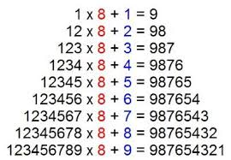

8-Write a program that takes an integer from the user and prints checkerboard pattern using nested loops.

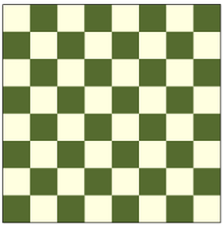
Examples:
Input: N = 4 Input: N = 5
Output: * * * * * * * * *
* * * * * * * * *
* * * * * * * * *
* * * * * * * * *
* * * * *

9- Write a program that prints the following shapes by using nested loops.

ABC
ABCDEFG
ABCDEFGHIJK
ABCDEFGHIJKLMNO
ABCDEFGHIJKLMNOPQRS

